**Assignment**

**Level-7 : Module-3**

Q1. Create a program to hide/show the password.

Ans.

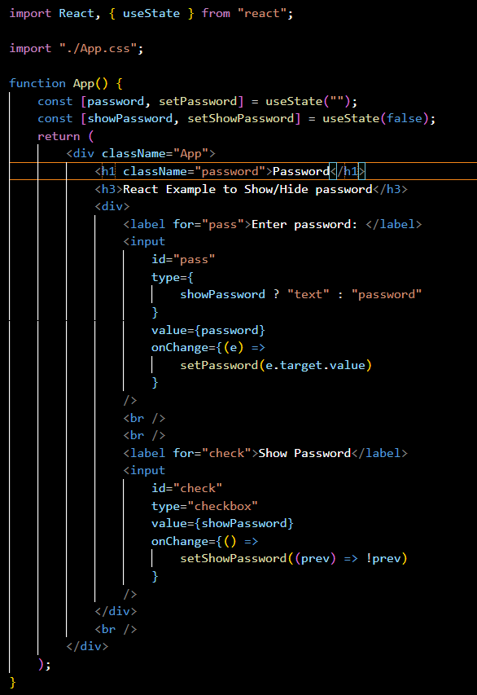

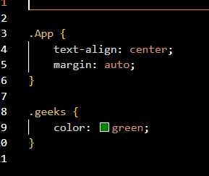

Q2. Create a program that will select all the classes and loop over and whenever iclick the button the alert should show.

Ans.

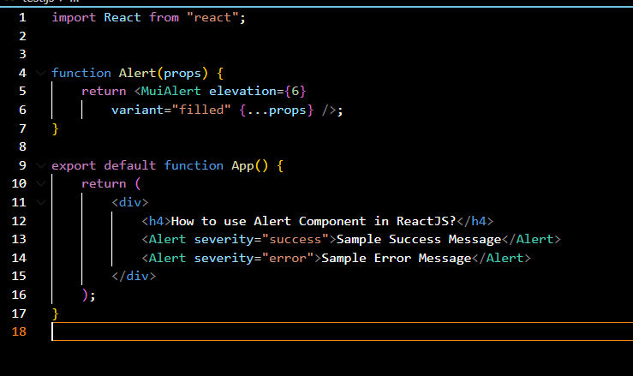

Q3. Create a responsive header using proper JavaScript.

Ans.

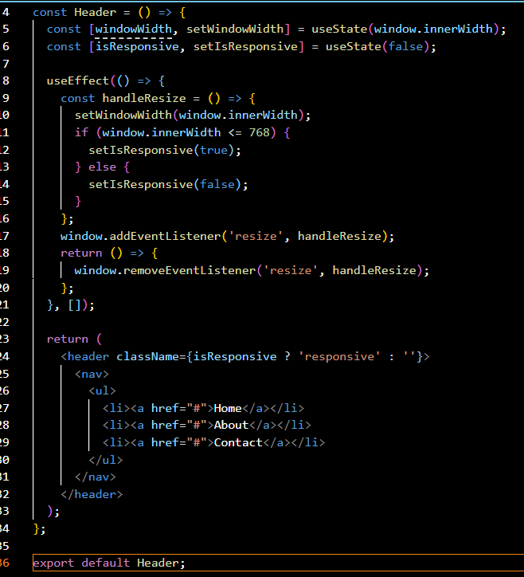

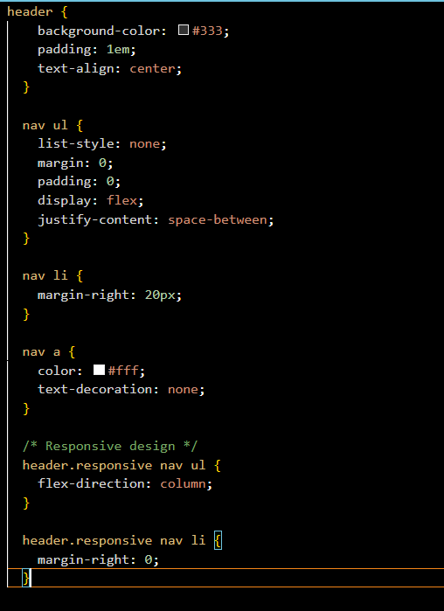

Q4. Create a form and validate using JavaScript.

Ans.

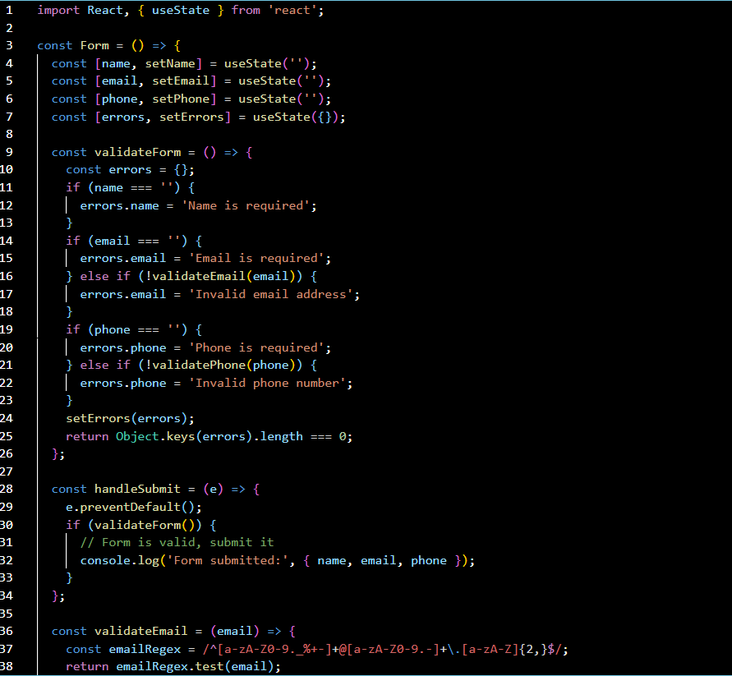

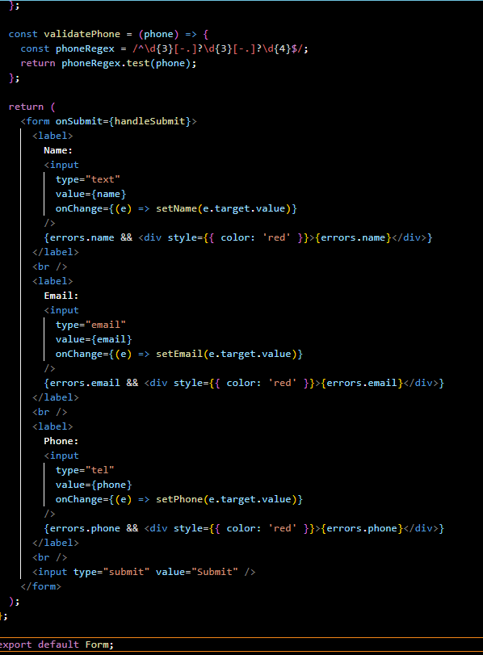

Q5. Create a modal box using css and Js with three buttons.

Ans.

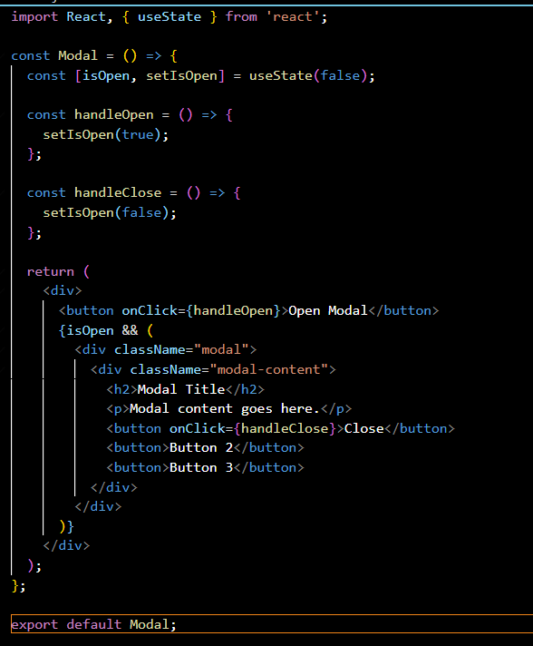

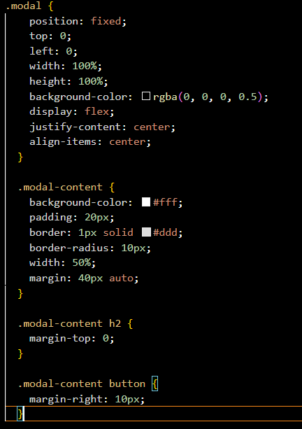

Q6. Use external js library to show slider.

Ans.

To use an external JavaScript library to implement a slider in a React app.

1. **Install the slider library** (if it's available on npm).
2. **Import the library** in your React component.
3. **Initialize and configure the slider** using the library's API within React's component lifecycle or hooks.
4. Optionally, manage the slider state in React if needed.

Q7. Prevent the browser when i click the form submit button.

Ans.

To prevent the browser from refreshing or navigating away when you click a form submit button in React, you need to use the event.preventDefault() method in the form's submit handler. This prevents the default behavior of form submission, which is to refresh the page.

